**ETH MIKE Trouble-shooting guide**

Software disconnects from hardware

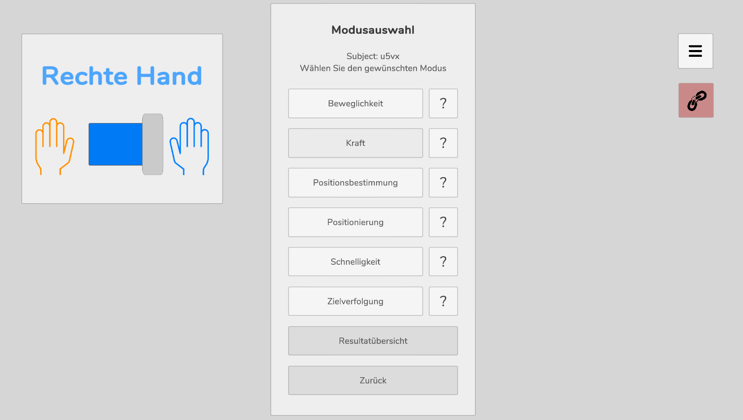

Hauptmenü

1. Make sure that the USB cable is connected (connecting the robot with the tablet).
2. Restart hardware (turn the switch on the side of the robot on and off)
3. Software: If you are in “Modusauswahl”, click on Hauptmenü button and there select Abmelden. Wait for the connection icon to turn green. Once it runs green and if you were not finished with last session, click “Letzte Sitzung fortsetzen” instead of starting new session (“Neue Sitzung starten”) with the subject code you were using when the robot disconnected.
4. If the robot disconnects during an assessment, go back to Modulauswahl (click “Zurück”) and wait until the icon turns green. Then repeat the assessment that was interrupted.
5. If the icon doesn’t turn green after you have tried steps 1-4, close the application (click “Beenden” in “Hauptmenü”).
6. Restart the robot again.
7. Open the application. Insert subject code and click “Letzte Sitzung fortsetzen”.

Software crushes

In case the software application suddenly closes, open it again and you will see the following pop-up. Confirm with “Ja” that you would like to continue and you will get back to where you were before the shutdown.

